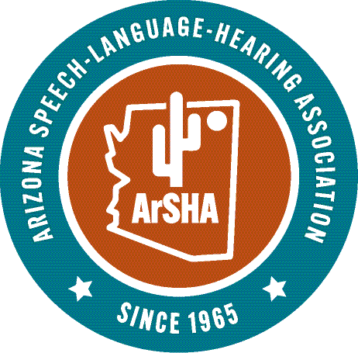
NOMINATION FORM

JAMES CASE STUDENT CLINICAL AWARD

Deadline: February 26, 2026

The James Case Student Clinical Award is presented each year to one outstanding graduate or doctoral student from Arizona State University, University of Arizona, Northern Arizona University, Midwestern, and A.T. Still University accredited by ASHA. The Director of Clinical Education at each university nominates two graduate/doctoral students who have demonstrated outstanding clinical potential; one who is enrolled in a graduate program in SLP and one who is enrolled in an AuD program in audiology*. The nominations, with all supporting documentation, are to be submitted to the ArSHA Honors and Awards Chair. All nomination materials are kept confidential. Nominators and all student nominees will be contacted by the committee. The following will be presented to each of the recipients of the award at the Honors and Awards Ceremony at the Arizona Speech-Language-Hearing Association Convention: An award certificate, an ArSHA check for $200, a waiver of the 2026-2027 ArSHA membership fee (this runs through the next full membership year), and a waiver of the two-day student registration fee for the 2026 ArSHA convention.

Name of Nominee:_____________________________________________________________
Current address:_______________________________________________________________
Home address:________________________________________________________________
E-mail address: __________________________________ Phone: _____________________
Current graduate student status:__________________________________________________

Anticipated graduation date:_____________________________________________________
REQUIRED COMPONENTS OF NOMINATION:
For each nominee, please submit the following to the ArSHA Honors and Awards Committee Chair:

- Completed nomination form
- Letter of nomination from the Director of Clinical Services clearly stating the qualifications of the nominee.

Submitted by: _______________________________________________________________
E-mail address: _________________________________ Phone:_______________________
Present Position: ________________________________ University: ____________________
SUBMISSION DEADLINE: February 26, 2026
All materials must be received by the deadline. The deadline cannot be extended
Submit this form and all nomination materials in 1 pdf folder or 1 email with all the appropriate documentation to: Kathleen E Peterson, AuD, CCC-A, ArSHA Honors and Awards Chair,
kepeterson5@me.com

*If there is no AuD program at the University, only one (1) nomination will be accepted.

