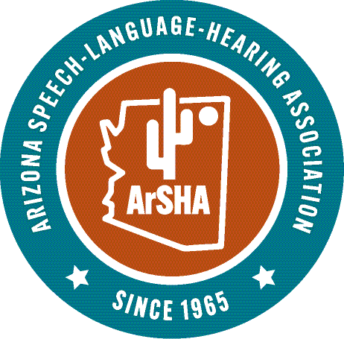
NOMINATION FORM
OUTSTANDING GRADUATE STUDENT SCHOLARSHIP
Deadline: February 26, 2026
Name of Applicant: ______________________________________________________
E-Mail: _________________________________Phone: _______________________
Address: _____________________________________________________________
University: ______________________________Degree program: _______________
Year in program: __________Anticipated graduation date: ______________________
Applicant’s ArSHA student number: _________________
Self-nomination is acceptable
Purpose: to recognize one current active ArSHA student member who has displayed strong clinical potential, leadership skills, and pre-professional involvement and service at the local, state or national level.
Eligibility: applicants must be current, active student members of ArSHA, part-time or full-time students in an Arizona university, enrolled in an accredited Communication Science and Disorders graduate degree program, have a cumulative, GPA of at least 3.25, have completed at least nine semester credit hours of the program, and have at least one full school year left in their degree program.
Scholarship amount: a scholarship of $500 will be awarded to each scholarship awardee. The recipient/s will be invited to the ArSHA Honors and Awards Ceremony during the Annual ArSHA Convention where they will be recognized and presented with the scholarship and a certificate.
Selection process: the scholarship recipient/s will be selected based on the student’s letter of application and essay, leadership skills, state or national pre-professional involvement, academic and clinical performance, and letter of recommendation, not financial need. The recipient/s of the scholarship will be notified by the ArSHA Honors and Awards Committee Chair by _____________, 2026. Those who applied but will not receive the scholarship will also be notified by the ArSHA Honors and Awards Committee’s decision by email at the same time.
Required components of the application:
_____ Completed application form
_____ An essay (600 words or less in total) that includes:

**A personal statement relating to the reasons you are pursuing a graduate degree in Communication Sciences and Disorders
**Future goals focusing on what you hope to contribute to the profession
**A description of undergraduate and/or graduate involvement in professional and pre-professional organizations, such as ArSHA, local chapters of NSSLHA and AAA Student Academy, as well as other leadership opportunitites in your university, such as student government, peer to peer mentoring, school newspaper, or in local/community projects and service.
**Any additional information that you think is pertinent
_____ One letter of recommendation (choose one of the two options):
- A letter of recommendation from a university faculty member regarding your clinical potential, leadership skills and related pre-professional involvement in service at the state level in ArSHA, AAA Student Academy or NSSLHA or at the national level in ASHA or NSSLHA……OR

- A letter of recommendation from an on-campus or off-campus clinical supervisor/preceptor regarding your clinical potential, leadership skills, and AAA Student Academy or NSSSLHA or at the national level in ASHA or NSSLHA.

_____ An official copy of your graduate transcript
_____A copy of your curriculum vitae or resume

SUBMISSION DEADLINE: February 26, 2026
All materials must be received by the deadline. The deadline will not be extended.
Submit this form and all nomination materials in 1 pdf or 1 e-mail with all the appropriate documentation attached to:
Kathleen E Peterson, AuD, CCC-A, ArSHA Honors and Awards Chair: kepeterson5@me.com

